TEST 2 AND ASSIGNMENT 1 FOR BSE 3105 (ADVANCED PROGRAMMING)
DUE DATES FOR TEST 2: 4TH NOVEMBER 2018 BEFORE MIDNIGHT
DUE DATES FOR CW IS : 14TH NOVEMBER 2018 BEFORE MIDNIGHT
NB: WE MIGHT HAVE CLASS PRESENTATIONS ON THE 15TH KINDLY TAKE NOTE
INSTRUCTIONS:
- The test should be done individually by each member of the class
- However, the coursework should be done in groups of four as the maximum number per group.
- The Report shouldn’t exceed 8pages
- To develop this application, you need to use any language of your choice such as Java/JSP/ HTML5/ Python/php along with Database connectivity.
- Each group should submit a hard copy and softcopy of their work to the classrep who shall be the only one to send me all the students work enclosed in one compressed folder
- All the work should be submitted through the classrep
- Finally, the classrep should also create a gmail group account that can be used by the different groups to upload all the work of the students easily since it shall be after the exams.
Marks shall be divided between the following two components:
- TEST 2
  - The writeup – 100%
The mark will be based on the following criteria:
- Extent to which specified the correct details
- independence plus the dependence of the security solution
- Security measures put in place
- Originality
- Neatness of the work
- The mark allocation

- COURSEWORK 1

  - Implementation of the web application – 100%
The mark will be based on the following criteria:
- Extent to which specified functionality is provided
- independence plus the dependence of the security attacks solution
- Security measures put in place
- Usability and speed of the application i.e. selection of colors and navigational flow
  - Report (maximum of pages) – 100%
- The report should briefly explain the objectives and the screen shots of the navigational flow of the application.
- You should indicate the technologies used and how you used them. The work should include application code The screen shots of the application plus sql dump of the database for both the demo vulnerable and non vulnerable applications

Plagiarism:
You should write the mark-up and scripts required for this assignment. Your report should be written in your own words. Anyone found to have copied from other students or from sources (such as the web, books and papers) without acknowledgement will receive zero marks.
Submission:
- Test two should be given to the classrep who has the mandate to provide me with the hard copies and the soft copies OR the classrep should create a gmail group account to which the students can upload the test with ease.
- The softcopy and hardcopy report consisting of coursework two should include all files(The screen shots of the application plus Mysql dump of the database for both the demo vulnerable and non-vulnerable applications) used in the implementations of the application in the report.
TEST TWO
QUESTION ONE

You are the Security Analyst on a team that built Lwomwax a major Social media company's chat Engine from its early planning stages to its completion. Your fellow Board members with whom you started the company have just established problems due to a glitch that happened unnoticed, and has affected the chat system’s chat transactions causing long waiting times for the system users that are trying to send and receive chat messages. This incident has the potential to decrease the company's revenues and profit margins that had exceeded US $50 billion dollars per annum if its customers and clients decide to seek for better services and refuge from the company’s biggest competitors and rivals such as Facebook, Whatsapp. The program developers have been asked to review the security implications through performing product threat modelling, Testing and evaluations plus various vulnerability scans to determined that the security bug in the chat transaction algorithm is not a big threat, although it has the potential to introduce additional vulnerabilities plus integrity issues and thus further investigations need to be carried out. You then recall the news reports about a similar incident on another system whose developers and company managers stated that this major problem must have been introduced during the design phase when the back-end and front-end modules of the system had been incorrectly connected, validated and sanitized.
- Briefly describe any two potential vulnerabilities that could be exploited in the said system above and explain how each one of them would be avoided.
- Describe how the vulnerabilities in (a) could be exploited
- Threat modelling is one of the activities that every organization should give considerable attention to, as it helps to systematically identify and rate the threats that are most likely to affect one’s system. If you had an option as an IT Manager, CEO or COO in the scenario above, why do you think choosing to model your organization’s threats would be the best option.
- Briefly describe the threat modelling steps and how you would have to use them in relation to the scenario above?
- With the help of a diagrams and the threat modelling steps above in (d) kindly perform steps 3, step 4, and step 6 using the appropriate diagrams and approaches for each case basing on the case scenario above.
- Describe how you have applied the twelve secure design principles to evaluate and interpret and thus arrive at the many threats to this application during your investigations. Then describe ultimately a set of protection requirements and mechanisms you have put in place to cub the threats so that we can offer the chat services securely and prevent any likely security incidents.
- With the help of the extract above describe and demonstrate how the attacks or vulnerabilities below work. The attack techniques that you need to explore to exploit the chat engine should include the following. NOTE Demonstrate the attack techniques against a demo web chat application.
- Cross-Site Scripting
- SQL Injection
- cross-site request forgery

- Describe and demonstrate the security measures and mitigations you have put in place to secure the web chat application from the attacks in(d) and any other vulnerabilities. NOTE Describe and Demonstrate the attack techniques against a demo web chat application with the help of screen shots.
- Briefly describe using two examples in each case in relation to extract above how exception, error handling and regular expressions can be applied for secure programming in relation to the extract above.

QUESTION TWO
In an attempt to reduce the dramatically increasing threats towards the same application in Question One, engineers and researchers at Lwomwax have decided as one of the attempts during further investigations to carryout various techniques of secure programming which include data sanitization. There have been many situation where the goal of data sanitization was to prevent untrusted data from exhibiting a certain kind of behavior. Exploiting input sanitization weaknesses can take many forms. For instance a user submitted a form seeking help consisting there user credentials but it returns with a validation error because the user failed to complete a required field. The form echoes back the users input so that the fields could be completed as showcased in the code below.
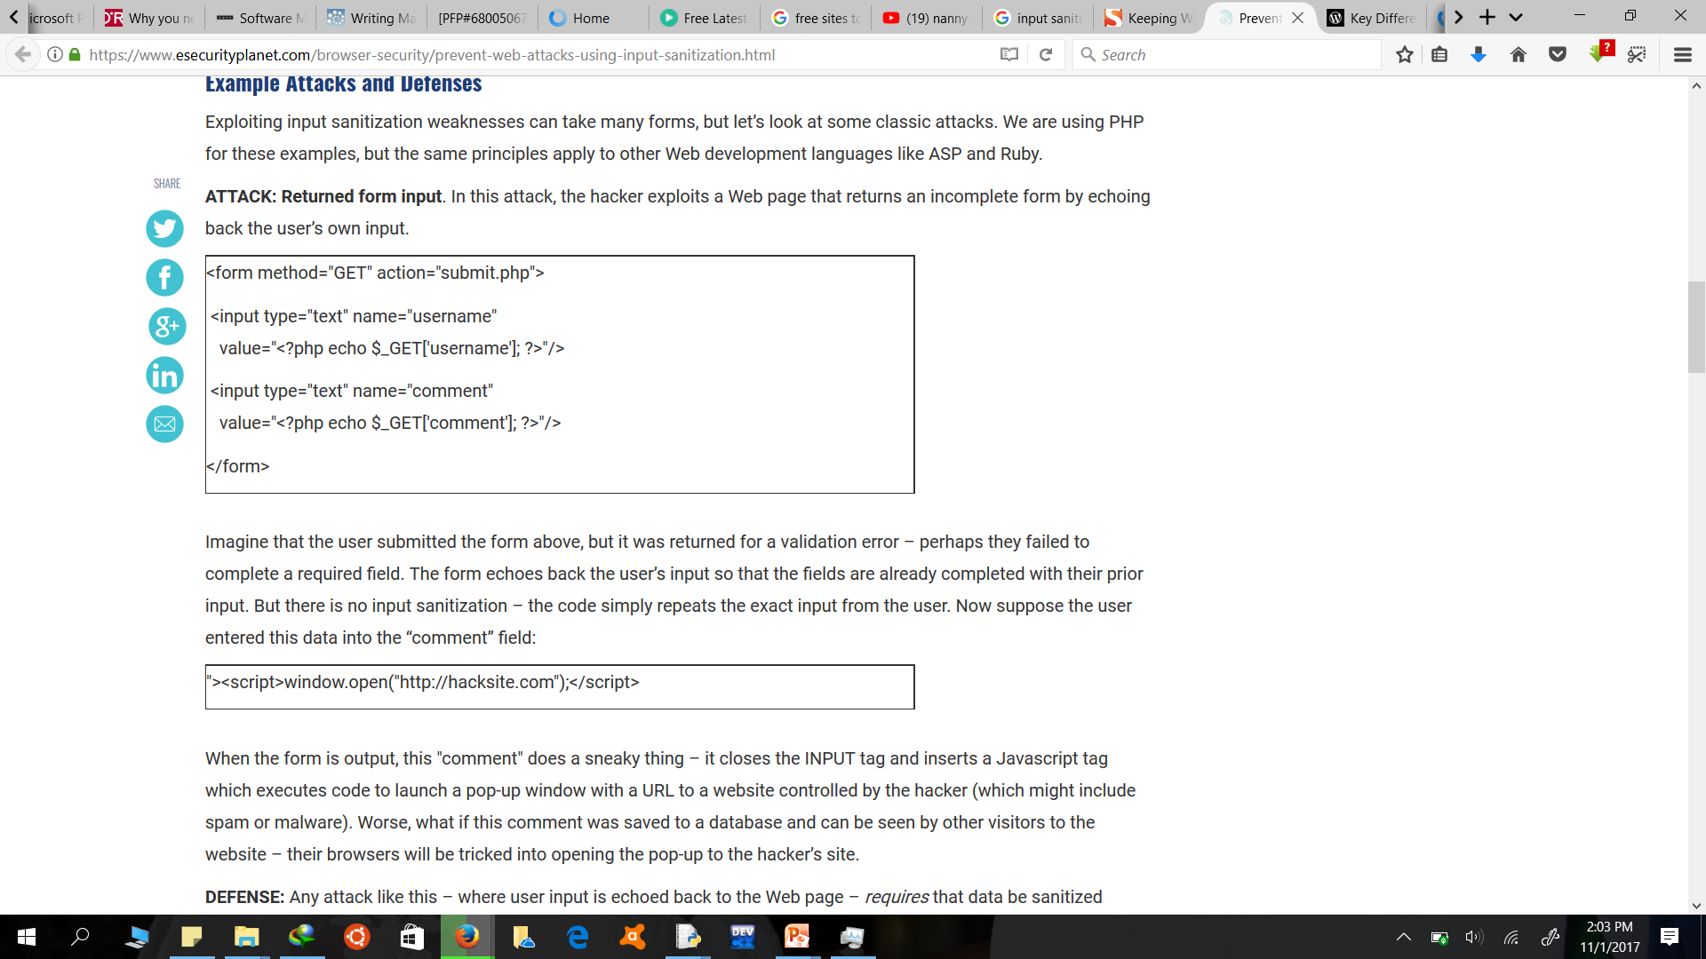

- Explain what is meant by input data sanitization
- Briefly Describe two vulnerability attacks that are likely to affect the code above
- Write a single line of code that can be used to address the vulnerability in the code above
- Describe two techniques that can be used to sanitize the code in the extract above
- Describe any other two secure programming practices or techniques that you could employ as Lwomwax’s systems security analyst.
- The developers argue that they have inspected their whole code base and made sure that only prepared statements are used for SQL. Explain whether that means they must be secure from an SQL injection.

COURSEWORK ONE A
Using the extract in Question One above, kindly imagine you are the Co author of Lwomwax and it’s in its beginning/inception; create the "chat" application engine, basing on the client/server socket framework and using languages of your choice. This socket chat engine should be able to connect to a simple database, and should also be able to communicate to other chat engines that have been developed by your other class groups that have their chat engines running on their computing devices thus making the whole class to communicate with each other. For one to access the chat environment they need to identify themselves through the use of access controls. The client should allow anyone viewing that Web page to chat with anyone else viewing the same web page. The server should be able to accept multiple incoming TCP connections, and broadcast any information it receives to all connections currently open.
After the creation of the above project answer the subsequent questions below.
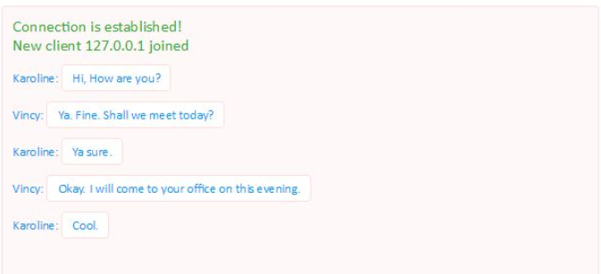
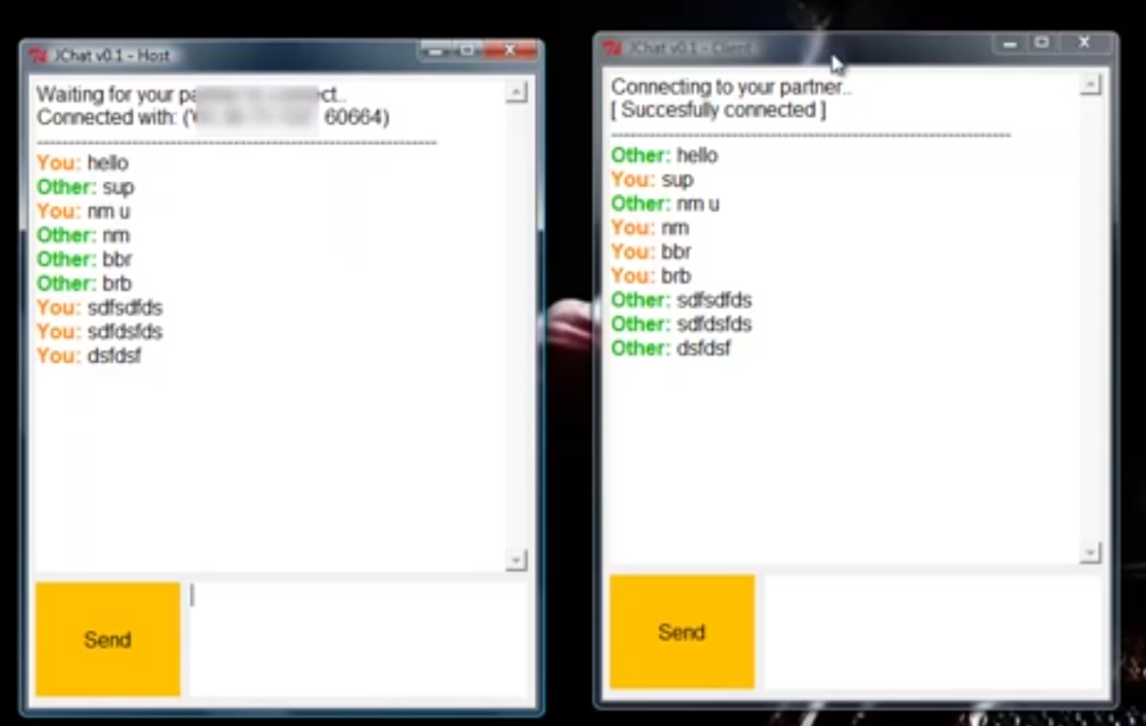
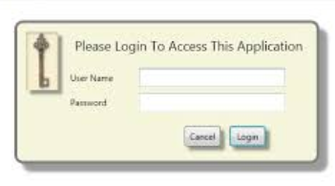
- Instead of reviewing all source code with equal focus describe how you managed to prioritize the security code review of source code components whose threat modeling ranked with high risk threats in step 3,4 and 6 of threat modelling for the application above.
- With the help of the application describe and demonstrate how the attacks below work. The attack techniques that you need to explore to exploit the chat engine should include the following. NOTE Demonstrate the attack techniques against a demo web chat application.
- Cross-Site Scripting
- SQL Injection
- cross-site request forgery

- Describe and demonstrate the security measures and mitigations you have put in place to secure the web chat application from the attacks in(d) and any other vulnerabilities. NOTE Describe and Demonstrate the attack techniques against a demo web chat application with the help of screen shots.
- Briefly show in your code creatively how you have applied exceptions, error handling and regular expressions in the chat engine above.

